

SENIOR CERTIFICATE EXAMINATIONS/

NATIONAL SENIOR CERTIFICATE EXAMINATIONS

MATHEMATICAL LITERACY P2

ADDENDUM

2019

This addendum consists of 3 pages with 2 annexures.

ANNEXURE A

QUESTION 4.1

 | Adapted road map of Welkom  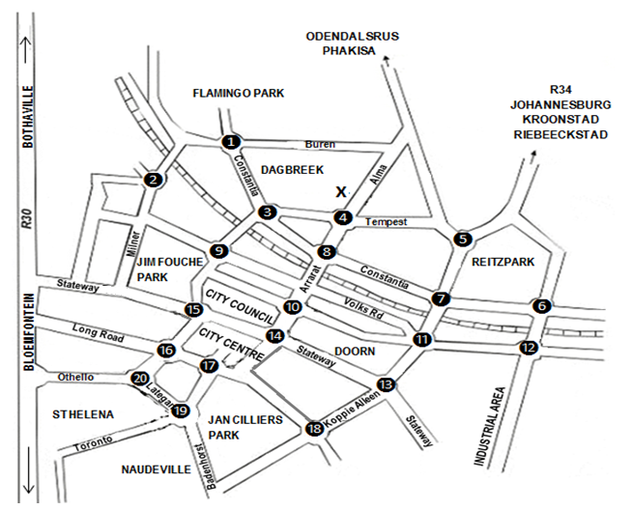  N  [Adapted from www.sleeping-out.co.za]  NOTE: The speed limit on public roads in an urban area is 60 km/h. | 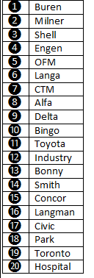  KEY:
  Symbol | Description
   | Rail
  R | Provincial road
   | Circles with names

ANNEXURE B

QUESTION 5.1

RAND VALUE OF COMPLAINTS RESOLVED IN FAVOUR OF THE INSURED PER CLAIM TYPE

2015
Commercial  R18 513 071 |  | 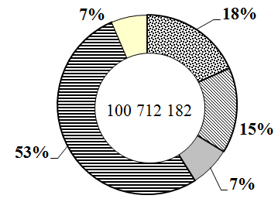  R100 712 182
Home owner
R15 498 565
Household
R7 339 724
Motor
____________

Other
R6 463 292

2016
7%
60%
7%
16%
10%
Commercial |  | 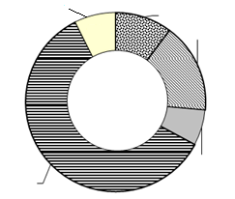
Home owner

Household

Motor
R59 438 533
Other

2017
Commercial  R19 982 717 |  | 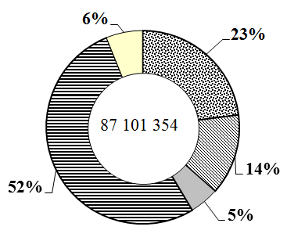  R87 101 354
Home owner
R11 829 111
Household
R4 280 912
Motor
R45 692 919
Other
R5 315 695
[Adapted from OSTI Annual Report, 2017]

