

SENIOR CERTIFICATE EXAMINATIONS/

NATIONAL SENIOR CERTIFICATE EXAMINATIONS

MATHEMATICAL LITERACY P1

ADDENDUM

2019

This addendum consists of 4 pages with 3 annexures.

ANNEXURE A

QUESTION 1.1


sUSAN vISSER  pO BOX 271  kIMBERLEY  8300
  STATEMENT DATE | 14 Jan 2017
  PAYMENT DUE DATE | 8 Feb 2017
  ACCOUNT NUMBER | 6007 585 **** ****
  INSTALMENT FREQUENCY | Monthly
lOAN STATEMENT
TRANSACTION DETAILS
DATE | STORE | DESCRIPTION |  |  | AMOUNT
30 dec 2016 | Head office | Debit order payment |  |  | 443,27 CR
14 jan 2017 | Head office | Monthly account fee |  |  | 38,00
14 jan 2017 | Head office | Total interest |  |  | 221,82
 |  | Fees and insurance
 |  | Opening balance |  | 35,00
 |  | Payment |  | 35,00-
 |  | Closing balance |  | 38,00
Loan taken on 09/10/2015 over
36 months
 |  | Opening balance |  | 2 658,20
 |  | Interest charged |  | 55,05
 |  | Payments |  | 153,46-
 |  | Closing balance |  | 2 559,79
Loan taken on 29/04/2016 over
60 months
 |  | Opening balance |  | 6 859,99
 |  | Interest charged |  | 144,04
 |  | Payments |  | 221,89 -
 |  | Closing balance |  | A
Loan taken on 10/10/2016 over
60 months
 |  | Opening balance |  | 1 081,89
 |  | Interest charged |  | 22,73
 |  | Payments |  | 32,92-
 |  | Closing balance |  | 1 071,70
 |  | Outstanding loan balance |  |  | 10 451,63
 |  | Loan amount available |  |  | 548,37
 |  | Next instalment due |  |  | 446,27
[Adapted from Woolworths financial document]

ANNEXURE B

QUESTION 2.1.4

PRICES AT A LOCAL STORE

 | Milo Option 1  R97,95 per unit  1 unit = 1 kg | 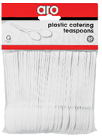 | Plastic spoons  R12,75 for  50 plastic spoons
 | Milo Option 2  R1 140,95 for  12 units × 1 kg | 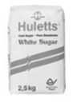 | Sugar  R33,20 per unit  1 unit = 2,5 kg
 | Foam cups  R1,78 for  1 foam cup | 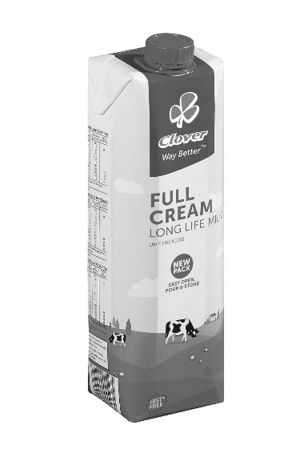 | Milk  R11,99 per unit  1 unit = 1 ℓ
[Adapted from www.makro.co.za]

ANNEXURE C

QUESTION 4.2

The map below represents the bus routes of a South African bus company.

Key:
Airport
National road
Bus stop
Bus route
N

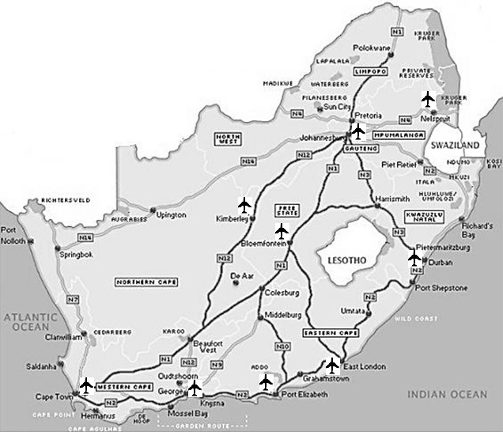
Scale: 1 : 10 000 000

